**Lesson 01 Demo 01**

**Creating CloudFormation Stack for Launching VM**

**Objective:** To create CloudFormation stack for launching VM

**Tools required:** AWS CloudFormation

**Prerequisites:** None

Steps to be followed:

1. Log in to the AWS Console
2. Create a new CloudFormation template to launch a new VM

**Step 1:** **Log in to the AWS Console**

* 1. Click on the Practice Labs tab and log in to the **AWS Console** from the **AWS Labs**

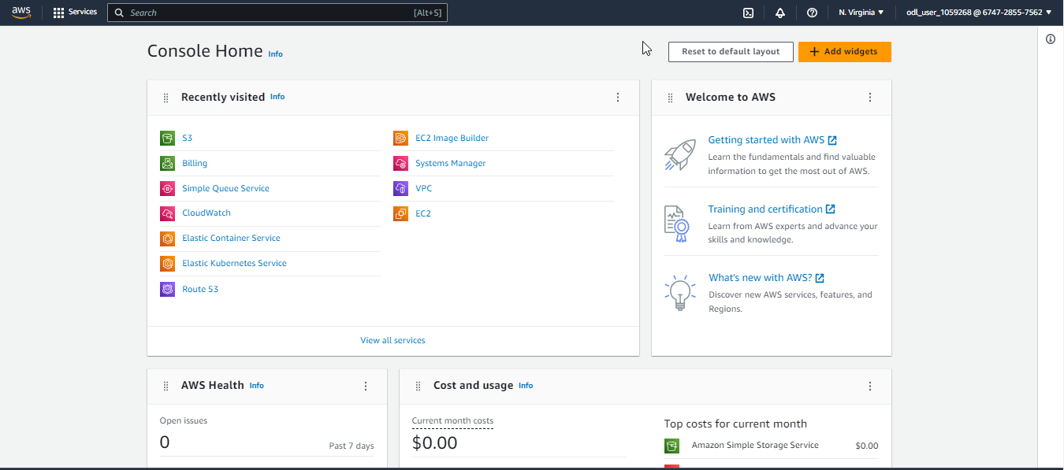

* 1. Search for and select CloudFormation in the AWS Console

**Step 2: Create a new CloudFormation template to launch a new VM**

1. Click on **Create stack** and select the **With new resources (standard)** option

1. In the Prerequisite - Prepare template section, select **Create template in Designer** and click on the **Create template in designer** button

1. Under the **new template** section, click on **Template** and add the Header, Parameters, and Resource components, which are shared below:

**AWSTemplateFormatVersion: '2010-09-09'**

**Description: Launch a t2.micro EC2 instance without a key pair**

**Resources:**

**EC2InstanceSecurityGroup:**

**Type: AWS::EC2::SecurityGroup**

**Properties:**

**GroupDescription: Enable HTTP and ICMP (ping)**

**SecurityGroupIngress:**

**- IpProtocol: tcp**

**FromPort: 80**

**ToPort: 80**

**CidrIp: 0.0.0.0/0**

**- IpProtocol: icmp**

**FromPort: -1**

**ToPort: -1**

**CidrIp: 0.0.0.0/0**

**EC2Instance:**

**Type: AWS::EC2::Instance**

**Properties:**

**InstanceType: t2.micro**

**ImageId: ami-0c02fb55956c7d316 # Amazon Linux 2 (update if needed for your region)**

**SecurityGroups:**

**- !Ref EC2InstanceSecurityGroup**

**Tags:**

**- Key: Name**

**Value: CFN-EC2-NoKeyPair**

1. Click on the **Validate** icon to validate the template, remove any errors, and click on the **Create stack** icon

1. Click on the **Next** button. Add the **Name,** specify other stack details, and click **Next** per the below screenshots:

1. Validate whether the stack is created per the screenshot:

1. Navigate to EC2 services to list all the available instance

With this, we have successfully created a CloudFormation stack and launched a VM.